🌟Subtraction 1° - Regrouping
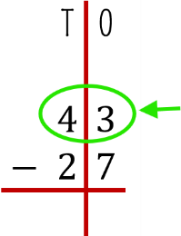  - Represent the number on top: | 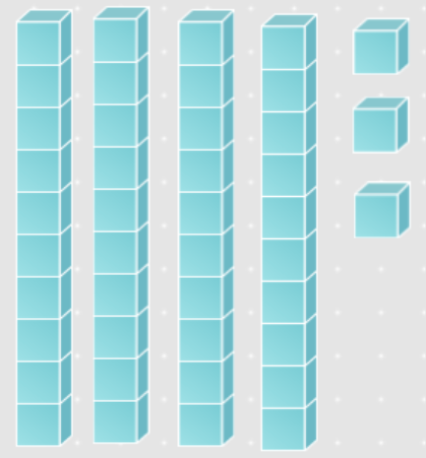
- Now start with the ones. Do you have enough ones to take away 7?  … No, you don’t have enough ones, so you need to regroup. This means take a ten and break it into ones. | 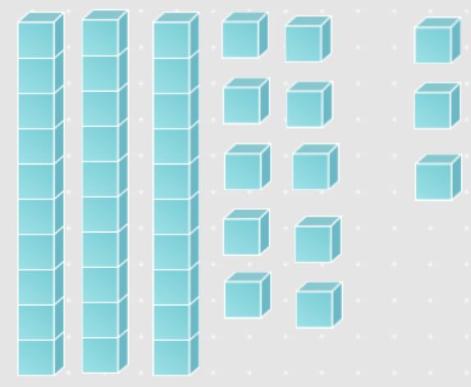
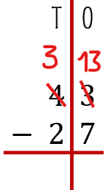  - Now, you have 13 ones and 3 tens: | 
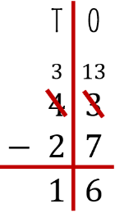  - Solve ones and then solve Tens: | 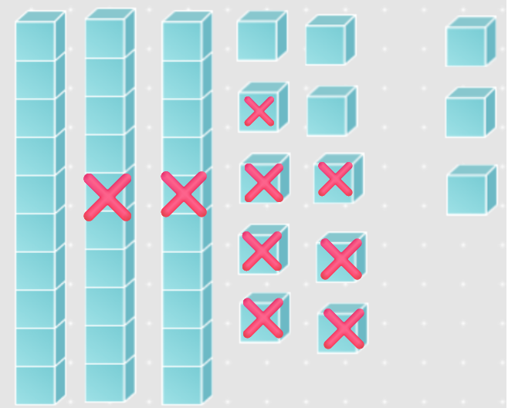
So $43-27=16$ | 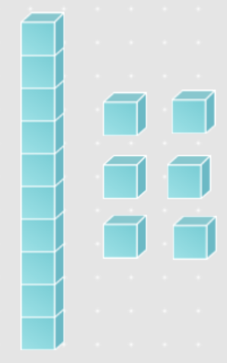

🌟Subtraction 1° - Regrouping
  - Represent the number on top: | 
- Now start with the ones. Do you have enough ones to take away 7?  … No, you don’t have enough ones, so you need to regroup. This means take a ten and break it into ones. | 
  - Now, you have 13 ones and 3 tens: | 
  - Solve ones and then solve Tens: | 
So $43-27=16$ | 

